# CHỦ ĐỀ: ĐIỆN THOẠI

1. **Tạo một trang web bán điện thoại**

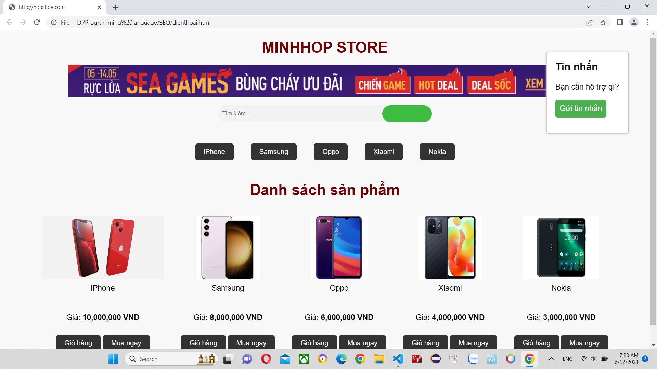

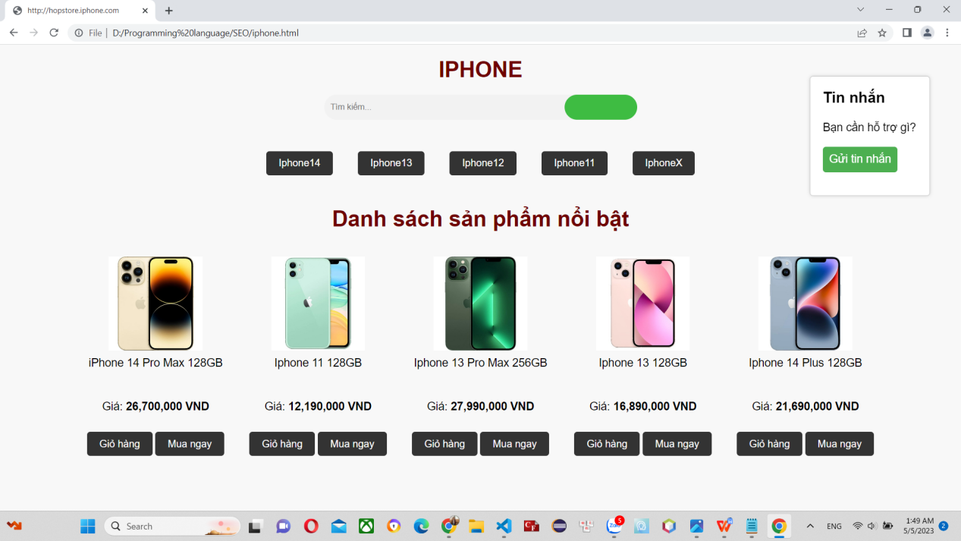

1. **Code**
2. **Trang chủ**

<!DOCTYPE html>

<html>

<head>

<title>http://hopstore.com</title>

<style>

body {

background-color: #f8f8f8;

font-family: Arial, sans-serif;

font-size: 16px;

}

h1,h2 {

font-size: 35px;

color: #6f0000;

text-align: center;

margin: 20px 0;

}

p{

font-size: 20px;

color: rgb(95, 93, 93)

text-align: center;

}

ul {

list-style: none;

margin: 0;

padding: 0;

display: flex;

justify-content: center;

}

li {

text-align: center;

margin: 20px;

}

img {

display: block;

margin: 0 auto;

}

p {

margin: 10px 0;

}

a {

display: inline-block;

padding: 10px 20px;

background-color: #333;

color: #fff;

text-decoration: none;

border-radius: 5px;

margin: 10px 0;

}

table {

border-collapse: collapse;

margin: 0 auto;

}

th, td {

padding: 10px;

text-align: center;

border: 1px solid #ccc;

}

th {

background-color: #f2f2f2;

}

tfoot td {

font-weight: bold;

}

.search-container {

display: flex;

justify-content: center;

align-items: center;

margin: 20px 0;

}

form {

display: flex;

justify-content: center;

align-items: center;

width: 500px;

height: 40px;

background-color: #f2f2f2;

border-radius: 20px;

}

input[type="text"] {

width: 80%;

height: 100%;

padding: 10px;

border: none;

border-radius: 20px;

background-color: transparent;

}

button[type="submit"] {

width: 25%;

height: 100%;

padding: 10px;

border: none;

border-radius: 20px;

background-color: #3ebc42;

color: #fff;

cursor: pointer;

transition: all 0.3s ease;

}

button[type="submit"]:hover {

background-color: #3e8e41;

}

.fa-search {

font-size: 16px;

}

.message-box {

position: fixed;

top: 50px;

right: 50px;

width: 150px;

height: 150px;

background-color: #ffffff;

border: 1px solid #ccc;

border-radius: 5px;

padding: 20px;

box-shadow: 0px 0px 5px #ccc;

}

h3 {

font-size: 24px;

margin-top: 0;

}

p {

font-size: 18px;

margin-bottom: 20px;

}

button {

background-color: #4CAF50;

color: #fff;

border: none;

border-radius: 5px;

padding: 10px;

font-size: 18px;

cursor: pointer;

}

button:hover {

background-color: #3E8E41;

}

</style>

</head>

<body>

<h1>MINHHOP STORE</h1>

<header>

<img src="./y.jpg" alt="" >

</header>

<div class="search-container">

<form>

<input type="text" placeholder="Tìm kiếm...">

<button type="submit"><i class="fa fa-search"></i></button>

</form>

</div>

<nav>

<ul>

<li><a href="file:///D:/Programming%20language/SEO/iphone.html">

Iphone</a></li>

<li><a href="#">Samsung</a></li>

<li><a href="#">Oppo</a></li>

<li><a href="#">Xiaomi</a></li>

<li><a href="#">Nokia</a></li>

</ul>

</nav>

<h2>Danh sách sản phẩm</h2>

<ul>

<li>

<img src="iphone.png" alt="iPhone" height="150">

<p>iPhone</p><br>

<p> Giá: <b>10,000,000 VND</b></p>

<a href="#">Giỏ hàng</a>

<a href="#">Mua ngay</a>

</li>

<li>

<img src="samsung.jpg" alt="Samsung" height="150">

<p>Samsung </p><br>

<p>Giá: <b>8,000,000 VND</b></p>

<a href="#">Giỏ hàng</a>

<a href="#">Mua ngay</a>

</li>

<li>

<img src="oppo.jpg" alt="Oppo" height="150">

<p>Oppo </p><br>

<p>Giá:<b> 6,000,000 VND</b></p>

<a href="#">Giỏ hàng</a>

<a href="#">Mua ngay</a>

</li>

<li>

<img src="xiaomi.jpg" alt="Xiaomi" height="150">

<p>Xiaomi </p><br>

<p> Giá: <b>4,000,000 VND</b></p>

<a href="#">Giỏ hàng </a>

<a href="#">Mua ngay</a>

</li>

<li>

<img src="Nokia TA-1029.jpg" alt="nokia" height="150">

<p>Nokia </p><br>

<p>Giá: <b>3,000,000 VND</b></p>

<a href="#">Giỏ hàng </a>

<a href="#">Mua ngay</a>

</li>

</ul>

<div class="message-box">

<h3>Tin nhắn</h3>

<p>Bạn cần hỗ trợ gì?</p>

<button>Gửi tin nhắn</button>

</div>

</body>

</html>

1. **Iphone**

<!DOCTYPE html>

<html>

<head>

<title>http://hopstore.com</title>

<style>

body {

background-color: #f8f8f8;

font-family: Arial, sans-serif;

font-size: 16px;

}

h1,h2 {

font-size: 35px;

color: #6f0000;

text-align: center;

margin: 20px 0;

}

p{

font-size: 20px;

color: rgb(95, 93, 93)

text-align: center;

}

ul {

list-style: none;

margin: 0;

padding: 0;

display: flex;

justify-content: center;

}

li {

text-align: center;

margin: 20px;

}

img {

display: block;

margin: 0 auto;

}

p {

margin: 10px 0;

}

a {

display: inline-block;

padding: 10px 20px;

background-color: #333;

color: #fff;

text-decoration: none;

border-radius: 5px;

margin: 10px 0;

}

table {

border-collapse: collapse;

margin: 0 auto;

}

th, td {

padding: 10px;

text-align: center;

border: 1px solid #ccc;

}

th {

background-color: #f2f2f2;

}

tfoot td {

font-weight: bold;

}

.search-container {

display: flex;

justify-content: center;

align-items: center;

margin: 20px 0;

}

form {

display: flex;

justify-content: center;

align-items: center;

width: 500px;

height: 40px;

background-color: #f2f2f2;

border-radius: 20px;

}

input[type="text"] {

width: 80%;

height: 100%;

padding: 10px;

border: none;

border-radius: 20px;

background-color: transparent;

}

button[type="submit"] {

width: 25%;

height: 100%;

padding: 10px;

border: none;

border-radius: 20px;

background-color: #3ebc42;

color: #fff;

cursor: pointer;

transition: all 0.3s ease;

}

button[type="submit"]:hover {

background-color: #3e8e41;

}

.fa-search {

font-size: 16px;

}

.message-box {

position: fixed;

top: 50px;

right: 50px;

width: 150px;

height: 150px;

background-color: #ffffff;

border: 1px solid #ccc;

border-radius: 5px;

padding: 20px;

box-shadow: 0px 0px 5px #ccc;

}

h3 {

font-size: 24px;

margin-top: 0;

}

p {

font-size: 18px;

margin-bottom: 20px;

}

button {

background-color: #4CAF50;

color: #fff;

border: none;

border-radius: 5px;

padding: 10px;

font-size: 18px;

cursor: pointer;

}

button:hover {

background-color: #3E8E41;

}

</style>

</head>

<body>

<h1>MINHHOP STORE</h1>

<div class="search-container">

<form>

<input type="text" placeholder="Tìm kiếm...">

<button type="submit"><i class="fa fa-search"></i></button>

</form>

</div>

<nav>

<ul>

<li><a href="#">Iphone14</a></li>

<li><a href="#">Iphone13</a></li>

<li><a href="#">Iphone12</a></li>

<li><a href="#">Iphone11</a></li>

<li><a href="#">IphoneX</a></li>

</ul>

</nav>

<h2>Danh sách sản phẩm nổi bật</h2>

<ul>

<li>

<img src="ip14prm.jpg" alt="iPhone" height="150">

<p>Iphone 14 Pro Max 128GB</p><br>

<p> Giá: <b>26,700,000 VND</b></p>

<a href="#">Giỏ hàng</a>

<a href="#">Mua ngay</a>

</li>

<li>

<img src="ip11.jpg" alt="iphone" height="150">

<p>Iphone 11 128GB </p><br>

<p>Giá: <b>12,190,000 VND</b></p>

<a href="#">Giỏ hàng</a>

<a href="#">Mua ngay</a>

</li>

<li>

<img src="ip13prm.jpg" alt="iPhone" height="150">

<p>Oppo </p><br>

<p>Giá:<b> 27,990,000 VND</b></p>

<a href="#">Giỏ hàng</a>

<a href="#">Mua ngay</a>

</li>

<li>

<img src="ip13.jpg" alt="iPhone" height="150">

<p>iPhone 13 128GB </p><br>

<p> Giá: <b>16,890,000 VND</b></p>

<a href="#">Giỏ hàng </a>

<a href="#">Mua ngay</a>

</li>

<li>

<img src="ip14pl.jpg" alt="iPhone" height="150">

<p>iPhone 14 Plus 128GB</p><br>

<p>Giá: <b>21,690,000 VND</b></p>

<a href="#">Giỏ hàng </a>

<a href="#">Mua ngay</a>

</li>

</ul>

<div class="message-box">

<h3>Tin nhắn</h3>

<p>Bạn cần hỗ trợ gì?</p>

<button>Gửi tin nhắn</button>

</div>

</body>

</html>